linear regression with one variable

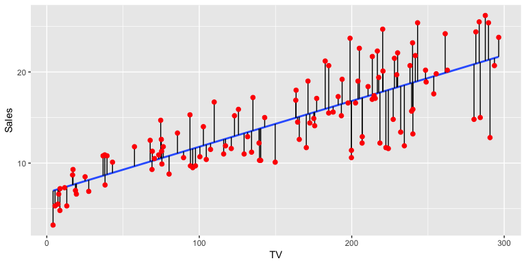Takes input variables and try to fit the output onto a continuous linear expected result function.

red dots: input

blue line: output

hypothesis function

$$h_{θ}\left(x\right)=θ_{0}+θ_{1}x$$

x = input feature

θ = parameters

This function outputs the hypothesized output with input x and parameters θ that defines the linear prediction.

cost function

$$J\left(θ_{0},θ_{1}\right)=\frac{1}{2m}\sum_{i=1}^{m}{{\left(h_{θ}\left(x^{\left(i\right)}\right)-y^{\left(i\right)}\right)}^{2}}$$

m = number of training example

y = answers to the training examples

This function takes in the parameters as the inputs and output the ‘cost’, or the effectiveness of the hypothesis using the input parameters by calculating the average squared sum error of each training example.

gradient descent

$$repeat until convergence\{$$

$θ_{0}≔θ_{0}-α\frac{∂}{∂θ_{0}}J(θ_{0},θ_{1})$

$θ_{1}≔θ_{1}-α\frac{∂}{∂θ_{1}}J(θ_{0},θ_{1})$

$\}$

α = learning rate

This iterative algorithm takes small steps at a time with the direction calculated by the partial derivatives multiplied by the scalar alpha towards a local optimum so that output calculated by the hypothesis function using the parameters will be the closest to the given output.

Remember that the thetas need to be updated simultaneously.

After calculating the partial derivatives:

$repeat until convergence\{$

$θ_{0}≔θ_{0}-α\frac{1}{m}\sum_{i=1}^{m}{{(h}_{θ}\left(x^{\left(i\right)}\right)-y^{\left(i\right)}})$

$θ_{1}≔θ_{1}-α\frac{1}{m}\sum_{i=1}^{m}{\left({(h}_{θ}\left(x^{\left(i\right)}\right)-y^{\left(i\right)}\right)x^{(i)})}$

$\}$